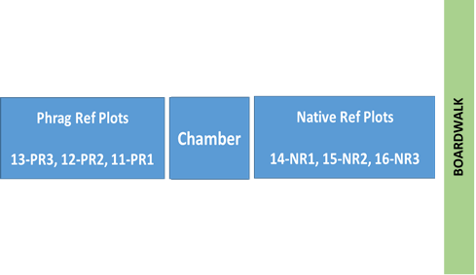
Location and Numbering Scheme for Phragmites x CO2 x N Experiment

Location and Numbering Scheme for Phragmites x CO2 x N Experiment



